**Class Diagram**

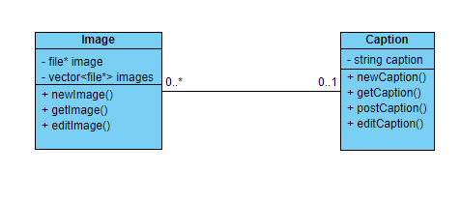

**Sequence Diagram**

